|  |  |
| --- | --- |
| rlbucolb | |
| **News Release** | |
|  | |
| Date: 14/09/2016 | Ref: 042/2016 |

**Liverpool Life Sciences Accelerator tops out!**

The £25m hi tech laboratory facility being built on Daulby Street has reached its highest point of construction. This milestone was celebrated by the Royal Liverpool and Broadgreen Teaching Hospitals, NHS Trust, the Liverpool School of Tropical Medicine (LSTM) and developer IHP with a topping out ceremony.

Those attending included the Deputy Mayor Cllr Ann O’Byrne and Colin Sinclair, executive director of the city’s Knowledge Quarter.

Aidan Kehoe, chief executive of the Trust thanked the LSTM, the City Council and said: “The Accelerator will be a fantastic asset to the city and is part of a vision for the city with the Knowledge Quarter creating an international hub for life sciences. The Accelerator is also the first part of a Liverpool Health Campus that will be built around it, bringing economic benefits and up to 5,000 jobs that will help improve the prosperity for the people of Liverpool.”

Professor Janet Hemingway, LSTM director said: “There is already a great deal of excitement from industry about the Accelerator, which will see us strengthening our already close research ties with the Royal, encouraging further international links as well as with local SMEs. It is an original offering which will put Liverpool very solidly on the map with its strong knowledge economy.”

Deputy Mayor Cllr Ann O’Byrne said: “The topping out ceremony recognises the skills and talent that are indigenous in the city of Liverpool. We are growing in our base for world class facilities and the Accelerator is one that will create jobs for local people, along with great opportunities for young people, graduates and apprentices. Liverpool is leading the way in health and wellbeing and it is at the heart of what we do, from life sciences and children’s centres to activities to get people fit and healthy, this all contributes to making Liverpool a great city.

Colin Sinclair, executive director of the city’s Knowledge Quarter added: “The Knowledge Quarter is a mayoral development zone within the city stretching from the waterfront all the way up to Lime Street. It is the biggest cluster of academic and clinical facilities in Liverpool and is also home to some of the most brilliant, innovative businesses working in science, life science and technology. Liverpool leads the world in fighting against infectious diseases and personalised medicine, this is proof Liverpool is a global city and we can compete with anyone, anywhere in the world. “

**ENDS**

For more information contact Jamie Murphy on 0151 706 5489 or [Jamie.murphy@rlbuht.nhs.uk](mailto:Jamie.murphy@rlbuht.nhs.uk) or Tor Shaw-Twigg on 0151 706 4781 or [tor.shaw-twigg@rlbuht.nhs.uk](mailto:tor.shaw-twigg@rlbuht.nhs.uk)

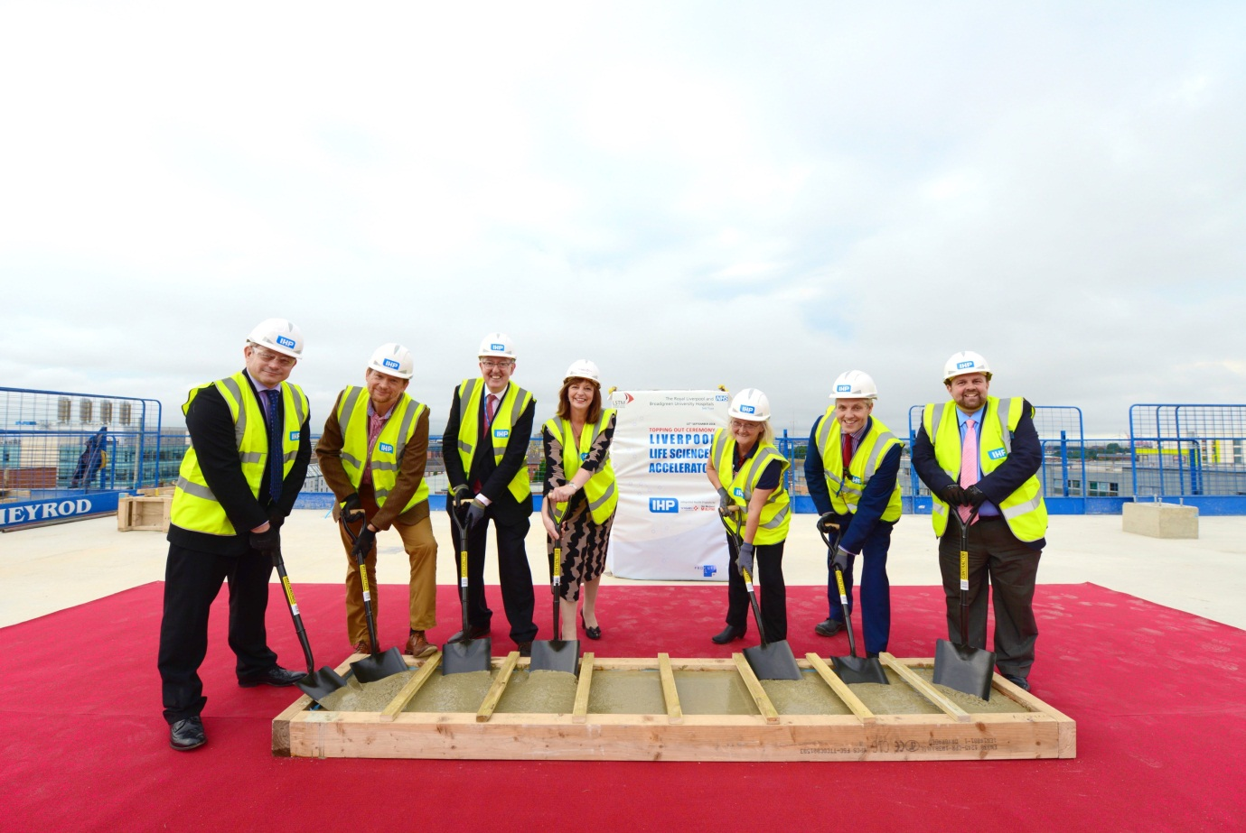**Photo 1 –** The topping out ceremony